Environment manual |  |  |  |  |  |  |  |  |  | 
Document no |  |  | RS-EM-01 |  |  |  |  | Written by |  |  |  | Mark.Kim
Rev no |  |  | 001
Rev. date | 2022.10.20 |  |  |  |  |  |  | Department |  |  |  | QM
Revised contents |  |  |  |  |  | Drift |  |  | Review |  |  |  | Approval
 |  |  |  |  |  | / |  |  | / |  |  |  | /
Revised Items | AS IS |  |  |  |  | TO BE
Agreement | QM | R&D
 | Opinion:


[Revision history]
Revision history summary |  |  | RS-EM-01
 |  |  | Revision | 001
 |  |  | Confidential | G1
Rev. no | Rev. date | Simple description of changed contents | Author | Post
001 | 2022.10.20 | Newly established.

- Definition of terms
  - Environment
Everything around us related with human life
  - Environment aspects
Elements of an organization’s activities, products, or services that interact with its environment.
  - Environment impact
The organization’s activities, products, or service, in whole or in part, changes that may have a negative or positive
Impact on the environment.
  - Environment management system.
The part of the overall management system, including the organizational structure, planning, activities, responsibilities and resources for developing, implementing, achieving, reviewing and maintaining an environment policy.
  - Environment management system audit
It is a systemic and documented verification process for that the organization’s environment management system is satisfied to ISO14001 requirements. And reporting these inspection result to the CEO.
  - Environment policy
A statement that describes the organization’s will and principles related to overall environmental performance that provides a framework for the organization’s environmental goals and targets setting and activities.
  - Environment goal
It should be quantified as much as possible as an overall activity goal set by the organization itself to achieve based on the environment policy
  - Environment performance
As a result of a measurable environmental management system, based on the organization’s environmental policy, environment goals and detailed goals, It is related to the management of environmental aspects of the organization.
  - Continual improvement
The process of strengthening the environmental management system to achieve improvement in overall environmental performance in accordance with the organization’s environmental policy
- Environment policy
ramsChip environment management policy

The ramsChip.Inc recognizes environment preservation as an value of corporate management and implements environmental management throughout corporate management for continuous corporate development and fulfillment of social responsibility.

- Ramschip develops eco-friendly products through design and research considering the environment
- Rasmschip comply with environmental law and other requirements.
- Ramschip participates in efficient use of energy and reduction of resources through controlling of energy which required in the entire process of business activities.

CEO Jaegan.Ko



  - Purpose & applied scope
The purpose of this procedure is operation of the efficient environmental management system though definition, maintain of environment policy.
This procedure is applied to all of activities for managing environment.
  - Responsibility and authority
2.2.1 CEO
-. There is responsibility and authority for approving environment policy
-. For efficient management of environmental policies and environmental management systems, an environmental management agent may be appointed and managed instead.
2.2.2 CQO
-. Review the necessity for the establishment and revision of the environmental policy
-. Establishment of environment policy and reflection related to environmental information on environment policy.
2.2.3 Each department leader
-. There is responsibility and authority for installing environment goals based on environment policy. And take training & education that is able to understand environment policy to all employees.
  - Working flow
2.3.1 Establishment of environment policy
CEO shall establish environmental policy considering organization’s activities, products, service, environment impact include the following items
-. Including of continuous improvement and pollution prevention.
-. Including the will to comply with environmental regulations and environmental requirements of the customer
-. Provides a system for setting and reviewing environmental target.
-. Documentation & maintain of environment management system.
-. If necessary, it should be disclosed to the relevant department or organization.
2.3.2 Reviewing & revision of environment policy
-. CQO reviews the suitability of the environmental policy at least once a year and revises it if necessary.
-. The environmental policy review should reflect changes in environmental conditions, changes in environmental regulations, the needs of government agencies and customer
2.3.3 Environmental policy implementation
-. Environmental policy should be trained and followed so that all employees can understand the contents.
-. Environment goal should be set based to environmental policy
-. The Environmental policy should be documentation and when necessary, it is posted in an appropriate place so that anyone can see it easily.

- Environmental aspect
  - Purpose & applied scope
The purpose of this article is for managing, maintaining continuously of the environment for which serious effect to environment. And it is applied to responsibilities, authorities and procedures for identifying and evaluating environmental aspects related to our activities, processes, products and services.
  - Responsibility & Authority
3.2.1 CQO
CQO have whole responsibility for investigating & evaluating of the environmental aspect and should monitor serious environmental effect.

3.2.2 Production manager
Production manager have responsibility for investigating of the environmental aspect regarding factory operation.

3.3.3 Material manager
The material manager has responsibility for investigation & evaluating of the environmental aspect regarding raw material.

3.3.4 Each department leader
The head of each department identifies the environmental aspects of the operation activity and conducts an environmental impact assessment, and information related to environmental aspects should be kept up to date.

  - Work flow
3.3.1 Each department should establish, implement and maintain following procedure
-. The process of identifying environmental aspects of an organization’s activities, products and services that are manageable by organization
-. A process for determining significant environmental aspects that have or are likely to have a material impact on the environment.
3.3.2 The head of each department identifies the environmental aspects and environment impacts of the department’s activities, processes, products or services in order to determine whether it has or is likely to affect the environment, and assesses the severity of the identified environmental impacts.
3.3.3 The head of each department should review the adequacy of the results of the environmental impact assessment conducted, and, if necessary, request a review from the Quality Assurance Office.
3.3.4 The head of each department must register and manage the serious environmental impacts resulting from the results of the environmental impact assessment in the environmental impact register. The quality management Office shall collect and maintain environmental impact registers received by each department
3.3.5 Severe environmental impacts identified through the environmental impact assessment are given priority, and environmental goals and detailed goals are given. This should be reflected when setting
3.3.6 Information relating to serious environmental aspects of our activities, processes, products or services must be kept up to date.
- Environment goal
  - Purpose & applied scope
Apply to responsibilities, authority and procedures for setting and maintaining documented environmental goals and targets to implement our environmental policy and improve environmental performance.
  - Responsibility & Authority
4.2.1 Quality management department
The Quality Assurance Office establishes company-wide environmental goals and detailed goals, and establishes environmental goals and detailed goals related to departmental business activities.
It is responsible for establishing and maintaining the environmental goals of each department by collecting and maintaining detailed goals. Responsible for checking the extent.
4.2.2 Each department leader
The head of each department should establish environmental goals and detailed goals related to the department's work activities, and send the environmental goals and detailed goals to the quality assurance office.
  - Work flow
4.3.1 Each relevant department establishes, documents, and maintains environmental goals and detailed objectives, and quantifies environmental objectives and detailed objectives if possible
4.3.2 Things to consider when establishing or reviewing environmental goals. Refer to the following
-. ramschip’s environmental policy
-. Environment regulation & others requirements related to ramschips job.
-. Serious environmental aspect identified by the environmental impact assessment.
-. Technical solution, financial, operation and business requirements.
-. Opinions or complaints of each team.
-. Overall environmental goals.
4.3.3 Environmental goals should be matched up with environmental policy, and the willpower for prevent pollution include.
4.3.4 Environmental goals should be revised, if there is revision of relevant law or changing of other requirements.
4.3.5 Each team should submit to the established environmental goals to the QM. And, QM should manage & maintain them to monitor environmental goals.
4.3.6 Environmental goals should be reviewed periodically for achievement & need to changing and if it needs to changing, have to inform to the relevant teams.
4.3.7 Each team should prepare environment management planning to achieve environmental goals. And it should be approved & reviewed by leader.
4.3.8 It should be included to the environmental management planning as below.
-. Responsible organization & person to achieve the goals.
-. Way & method to achieve the goals.
-. Proceeding schedule
4.3.9 The relevant team has to submit the environmental management planning to the QM. And QM should manage them to manage & maintain environmental management system.
4.3.10 Each team has to do improvement actions according to environmental management planning, and they should submit them to the QM periodically. And if there is some event as below, they have to distribute the revised planning to the management team after approved by team leader.
-. Changing of process, machine and facility
-. Revision of environmental goal.
-. Revision of environmental management planning.
- Environmental management plan
  - Purpose & applied scope
It is applied for establishing of documented environmental goal & plan to improve environmental performance
  - Responsibility & authority
5.2.1 Quality management division
QM has responsible for establishing of overall environmental goal relevant working activities and maintaining of environment goal each team and reviewing of achievement its
5.2.2 Each team leader
Each team’s leaders should submit the environment goals related to work activities to the QM team.
  - Work flow
5.3.1 Each team should establish environment management plan to achieve environment goals. And should be approved by manager.
5.3.2 It should be included to the environmental management planning as below.
-. Responsible organization & person to achieve the goals.
-. Way & method to achieve the goals.
-. Proceeding schedule
5.3.3 The relevant team has to submit the environmental management planning to the QM. And QM should manage them to manage & maintain environmental management system.
5.3.4 Each team has to do improvement actions according to environmental management planning, and they should submit them to the QM periodically. And if there is some event as below, they have to distribute the revised planning to the management team after approved by team leader.
-. Changing of process, machine and facility
-. Revision of environmental goal.
-. Revision of environmental management planning.
- Structure & responsibility
  - Purpose & applied scope
Define to responsibility & authority for all of employees who take impact to the environment management system and it is applied to working procedure through define to role & role of all of functionable employees.
  - Organization & general
6.2.1 The organization to implement environment management system is described on quality manual’s phase 3.
6,2,2 The leader of each team is able to mandate environment relevant task to the charged person within organization. But, the its responsibility for environment activities only has him.
6.2.3 Responsibility & authority of charge persons who are a implementing, monitoring for environment task is defined in the each items of this manual.
6.2.4 Each department head should assign duties to department members and document the responsibilities and authorities related to them in an appropriate way.
  - Responsibility & Authority
6.3.1 CEO
-. Establishing of environment policy
-. Providing of human resource, materials, finance for maintaining of environment management system
-. Decision & final review about management review result.
-. Appointment of environment management agent
-. Overall responsibility for the implementation of the environmental management system and performance.
-. Approval of environment manual & instruction.
-. Approval of environment goals
-. Supervision of management review to ensure suitability, and effectiveness of the environmental management system.
6.3.2 Production management officer
-. Execution and maintenance of environmental management system.
-. Revision of relevant document for environmental management system.
-. Execution and maintenance of environment impact assessment
-. Establishment of the environment goals. And managing of performance.
-. Request for corrective & preventive measures for problems related to the environmental management system and confirmation of action results.
-. Identification, analysis, monitoring and measurement of environmental influence factors and pollutants.
-. Internal audit for environment management system.
-. Report to environment management performance to the CEO
-. Establishing for emergency plan
6.3.3 Quality management officer
-. Implementation & maintenance of environment impact assessment
-. Monitoring & review of environment management performance of each team.
-. Survey for environmental regulation & others requirement. And distribute surveyed information to each team.
-. Confirmation of the achievement for environmental goals and implementation status of environmental management promotion plan.
-. Integration all of information relevant about emergency & global regulations.
6.3.4 Common
-. Implementation of environmental impact assessment. And establishing for environmental goals.
-. Performance management of environmental management plans & goals.
-. Compliance with environmental laws and other requirements.
  - Resource
6.4.1 CEO & CQO should provide suitable resources which need to manage environmental system.
6.4.2 Required resources for implementation & maintenance of environmental management system.
-. Provision of qualified internal auditors.
-. Cost needed to meet environmental goal.
  - Organization
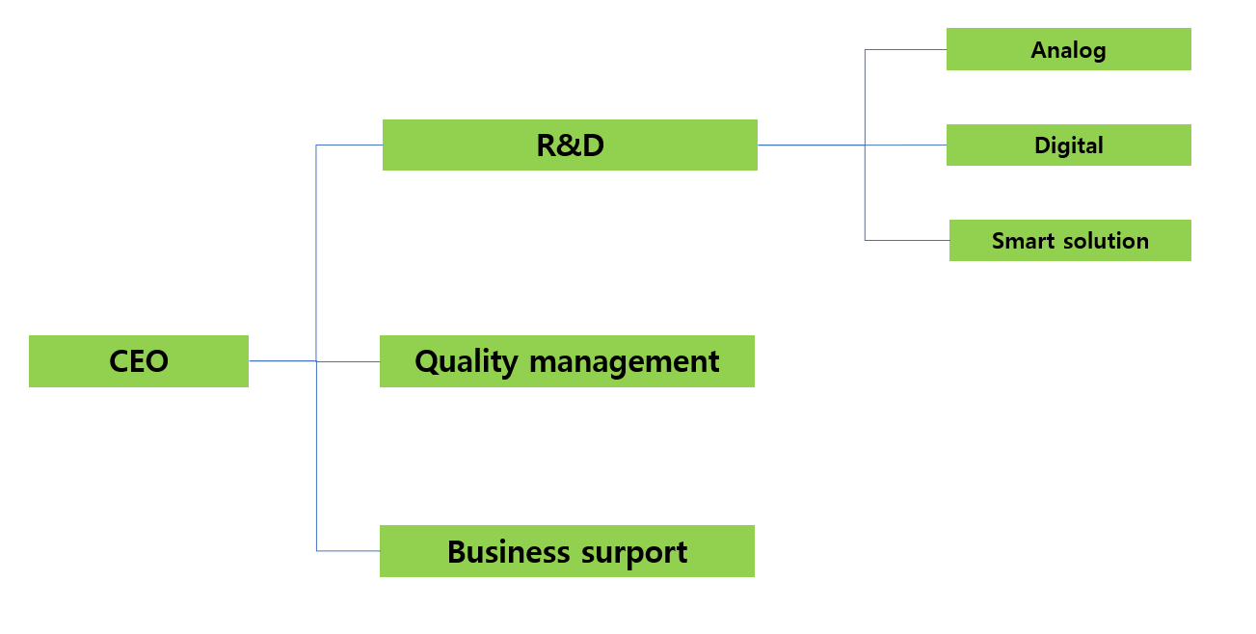
- Education & training
  - Purpose & applied scope
Identification of training needs for all personnel performing work that may have a significant impact on the environment and it applies to the responsibilities, authorities and procedures for conducting training and managing the qualifications of personnel performing specific environmental tasks.
  - Responsibility & authority
7.2.1 CQO has overall responsibility for environmental education & training.
7.2.2 CQO has to maintain & manage for training & education recording & certification of specific environmental charged persons.
7.2.3 Each department team leader is responsible for identifying the need for education & training for department members and implementing the education & training.
  - Work flow
7.3.1 Education & training
-. The relevant department identifies the need for education & training for personnel performing work that may have a serious impact on the environment and personnel performing work on behalf of our organization, and conducts appropriate training.
-. Each department should notice our company’s environment policy, goals, plans to the department members through education & training.
-. Each department should make up education plan let members recognize below.
>. The need to comply with environmental policies, procedures and environmental management system requirements.
>. The serious environmental impact of each individual’s working activities on the environment and the environmental benefits of improving personal performance.
>. Possible consequences of not complying with the prescribed operating procedures.
7.3.2 Human resource management
-. For personnel performing specific environmental tasks that may have a serious impact on the environment, qualification criteria are set based on education, training and experience for the task, and the appropriate person is assigned to perform the task.
- Documentation of environmental management system.
  - Purpose & applied scope
To ensure that ramschip effectively achieve our environmental policy & goals based on ISO14001 standard
  - Responsibility & authority
8.2.1 The CEO is overall responsible for the establishment, documentation and maintenance of the environmental management system and the environment manual. And he has the authority to approve procedure.
8.2.2 CQO is responsible for the review of environment manual, procedure, work instructions.
8.2.3 CQO is responsible for the establishment, implementation & maintenance of the environmental management system. And he should manage relevant environmental documents.
8.2.4 The leader of each department is responsible for the implementation of the environmental management system according to identified procedure.
  - Items included in environmental management system documentation
-. Environment policy, goals
-. Applied scope of environment management system.
-. Major construct of environment management system. And inter-action between them.
-. Recording, required documentation
  - Environmental management system.
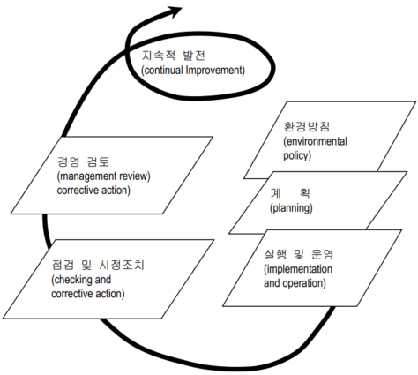
  - Environmental management system documentation
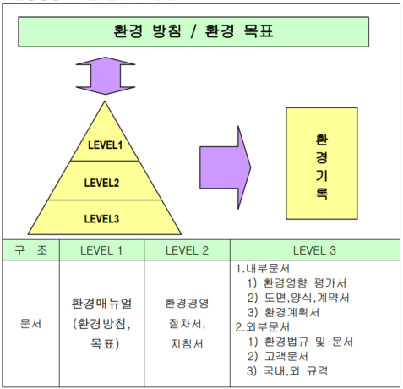
- Document management
  - Purpose & applied scope
To ensure preparing, approval, revision & distribution of document related to environmental management system
  - Responsibility & authority
9.2.1 CEO is overall responsible for establishing of environment management system and has authority for approval relevant environment procedures.
9.2.2 CQO is responsible for review of environment manual & procedures.
9.2.3 CQO is overall responsible for managing, revision, distribution of environment relevant document
9.2.4 Each department leader is responsible for establishing, revision & distribution of the relevant procedure & instruction related to environment management.
  - Work flow
9.3.1 draft, review and approval of documents
-. The document should be described to the draft & revision date.
-. The document should be a review, approval before released.
-. The document always should be maintained to the latest version. And, should possible for tracking of document version.
9.3.2 Distribution & management of the documents
-. The approved document should be distributed to the relevant department. And should be maintained a distributed date.
-. The environment manual, procedure & working instruction should be periodically reviewed for adequacy. Document should be revised if necessary.
-. The document should be easily accessed if user’s necessary. And it should be managed according to defined storage period.
9.3.3 revision of document
-. The revision of documents should be proceeded according to same as drafting process
-. The revision history of document should be described clearly in documents.
- Emergency management
  - Purpose & applied scope
All of activities & tasks should be managed for potential environment accident & emergency event efficiently. The responsibility & authority of each relevant person are classified for managing of emergency event well as below.
  - Responsibility & authority
10.2.1 CEO
CEO is overall responsible for managing of the emergency events.
10.2.2 CQO
CQO should investigate potential risk for emergency event. And has to prepare emergency plan to treat emergency event. and is overall responsible for training of emergency events.
10.2.3 The head of each department.
The head of each department should investigate potential risk for environment, and should implement suitable activities according to emergency plan.
  - Work flow
10.3.1 The head of each department investigate for potential environment risk and should implement classified activities according to emergency plan.
10.3.2 it should be included the countermeasures which let make prevention of environment impact caused by emergency events within emergency planning.
10.3.3 emergency plan should be a revision & review if necessary.
10.3.4 The head of each department should implement a training according to emergency plan if it’s possible.
- Monitoring & measurement
  - Purpose & applied scope
Apply responsibilities, authorities and procedures to regularly monitor and measure key characteristics of our operations and activities that may have a significant impact on the environment
  - Responsibility & authority
11.2.1 CEO
The CEO is responsible for the achievement of environmental goals, including compliance with environmental laws, other requirements and environmental management plans. Responsible for overall performance management.
11.2.2 CQO
CQO monitors compliance with environmental laws, regulations and other requirements, achievement of environmental management plans. Responsible for overall monitoring and measurement of environmental operation activities, including monitoring of implementation performance.
11.2.3 Head of each department
The head of the relevant department is responsible for the achievement of department’s environmental goals, the performance of the environmental management system plan, and the compliance with related environmental laws and regulation. Identify critical characteristics of departmental operations and activities that may have significant impact on compliance and the environment, and implementing monitoring and measurement items and frequency.
  - Work flow
11.3.1 QM department should investigate for significant characteristics which make serious impact on the environment. And should define for its monitoring & measurement cycle.
11.3.2 The relevant departments should implement for defined monitoring & measurement items as set frequency. And it should be recoded their history.
11.3.3 Monitoring & measurement should be included compliance of the environment laws, other requirements, and it should be managed periodically them.
11.3.4 Monitoring & measurement should be included the information of environment management performance & achievement of environment goals.
11.3.5 The head of each department should monitor for compliance of the relevant laws, regulation & other requirements, and if there is the finding issue at monitoring, they have to do improvement actions according to relevant procedures.

- Nonconformity & corrective action
  - Purpose & applied scope
Responsibilities, authorities and procedures are applied to effectively carry out corrective and preventive measures to prevent the recurrence of nonconformities found during monitoring and measurement and the occurrence of potential nonconformities.
  - Responsibility & authority
12.2.1 Environment manager is responsible for countermeasure of the nonconformities and approval of preventive actions.
12.2.2 CQO has overall responsibility for preventive & corrective actions of the nonconformities, and he should confirm the result of the corrective actions and has to keep relevant recording.
12.2.3 The head of relevant departments have to make a countermeasure, define of root cause for real & potential nonconformities, after that they should implement suitable activities.
  - Work flow
12.3.1 The countermeasure & preventive actions to eliminate real & potential nonconformities cause should be defined according to impaction & volume of the troubles.
12.3.2 The CQO should request the corrective actions for environment nonconformity to the head of relevant departments
12.3.3 The head of relevant department who are requested to corrective actions from CQO or Environment manager should implement to the corrective action & root cause define. After that, they have to notify the result of corrective actions to the requestor.
12.3.4 CQO must confirm that the corrective actions are completed well. And he has to guarantee maintaining of environment management system.
12.3.5 CQO or environment manager should investigate the cause of potential nonconformity, and they have to do the preventive action for investigated nonconformity, or should request them to the relevant department.
12.3.6 The relevant department should implement the preventive actions to eliminate potential nonconformity, and CQO or environment manager should mange that the preventive actions was done.
- Environment management system audit
  - Purpose & applied scope
Evaluate whether the our environmental management activities and results are effectively carried out according to the plan, and apply to the responsibility, authority, & procedures for planning and conducting internal environmental reviews to determine the effectiveness of the environmental management system.
  - Responsibility & authority
13.2.1 CQO
CQO establishes an internal audit plan, assign internal auditors, and implement environment internal audit. After that report the audit result to the CEO and be responsible for notifying the audited department.
13.2.2 The head of relevant department
The audited department’s leader should cooperate on the internal audit, they should carry out improvement actions for nonconformities which were found at internal audit. And then, should be notified to the CQO.
13.2.3 The auditors execute to the environmental internal audit, and they should notify for the nonconforming items to the audited department. And then they have to check again for improvement actions.
  - Work flow
13.3.1 Audit frequency & mode
-. The internal audit should be implemented once per year and it is able to do irregular internal audit under CQO’s decision as below.
>. At occurrence of the serious environmental accident
>. At significant changing of the environmental management organization & functions.
>. At continuous recurrence of founded nonconformities at audit.
13.3.2 Audit plan
-. CQO should obtain approval a internal audit plan on the basis of the operation status of audited department from CEO
-. CQO has to prepare internal audit plan, including below.
>. Environmental internal auditors.
>. Audit scope & audit items each department.
>. Audit schedule, method, etc.
-. The internal auditor must be assigned as an independent person who does not direct responsibility for the work to be audited as person who meets prescribed qualifications, and must be assigned sufficient persons.
13.3.3 Report of the audit result
-. If the internal audit is done, the leader of audit team should submit internal audit result to the CQO. And then CQO report them to the CEO.
-. In audit report, it should be included to the audit scope, auditors, audit result summary & finding items.
13.3.4 Corrective actions & confirmation
-. CQO has to request the corrective action to the relevant department for founded nonconformities at audit.
-. The relevant department’s leader should carry out the corrective actions within due date, and he has to notify actions result to the QM.
-. QM engineers or internal auditors confirm whether implement the corrective actions effectively. And they record the confirmed result on the nonconformity report.
- Management review
  - Purpose & applied scope
To guarantee our environment policy, environmental goals & ISO14001 requirements,
  - Responsibility & authority
14.2.1 CEO
The CEO is responsible for management review & final decision of reviewed agendas.
14.2.2 CQO
The CQO is overall responsible for preparing of management review agenda & executing of the meeting. And he should confirm & track management review results.
14.2.3 The head of each department
The head of each department has to do improvement action for the issued items from management review.
  - Work flow
14.3.1 CEO should carry out management review to guarantee environment management system once per year, and he is able to hold management review meeting irregularly in case of below.
-. At occurrence of serious environment impact due to changing of relevant environmental laws.
-. In case of the field requirement is given serious environment impact on company’s management.
-. At occurrence of serious environment impact due to process improvement or new technology development.
14.3.2 CQO should prepare the management review agenda, date and has to notify them to hold management review meeting efficiently.
[Management review agenda]
-. Environment internal audit result, compliance of the environmental laws, regulations & other requirements.
-. Environmental performance of the organization
-. Inter-communication with external relevant organization or person, including complaint.
-. Achievement of environmental goals
-. Status of the corrective action & preventive actions.
-. Following activities of the previous management review issues.
-. Evaluation of the suitability of the environmental policy and the need for change.
14.3.3 Action of management review result and following management
-. It should be prepared management review report for reviewed result & decision.
-. CQO has to notify management review result which need to improvement actions to the relevant department leader
-. The head of relevant department should carry out improvement actions for issued nonconformity.
-. CQO confirm improvement actions which are implemented from relevant department, and he has to report & reflect them at next management review.

